Blank Feed

**GAME DESIGN DOCUMENT**

Table of Contents

-Game Team Overview-

Roles & Responsibilities

Contact Information

Values and philosophy

-Game Overview-

Essence Statement

Gameplay Overview

Key Features

-Business Development Vision-

High Level Project Goal

PC game

Environmental Puzzle Horror

What do we want out of this?

Timeline & Budget

Target Market

Player Profile

Bryan’s Fun Defined

Bryan’s Anti Fun Defined

Market Opportunity/Need State

Market Competition

Companies

Games

Movies / Shows

Business Model

Product Distribution Model

Retail Sales Model

Product Type

Online Connectivity

Platforms

Core Technology

-Game Vision-

Game Genre & Abstract Game Concept

Concepts

Core Game Experience

The Situation

The Setting

The Story (Narrative)

Game Experience Pillars

Emotion Style & Tone

Player Mindset

Actions

Presentation Pillar

Art Style Pillar

Sound Pillar

Seeing enemy

Features

Core Features

Supporting Features

Product Differentiation & Innovation

What makes this game different?

Old Features and Gameplay Elements

Improved Features and Gameplay Elements

Re-Purposed Features & Gameplay Elements

New Features & Gameplay Elements

-Gameplay-

Player Goals & Gameplay Objectives

Player Goals

Objectives

Win Condition

Mechanics

The Monster

Aesthetics

Mechanics

Rewards

Punishment & Lose conditions

Temporary Routes:

Gameplay Flow & Structure

Player State

Gameplay Moments

Running

Past Moment

Present

Next Moment

Searching

Past Moment

Present

Next Moment

Hiding

Past moment

Present

Next moment

Challenge Flow

Game Progression

Help & Tutorials

Game Options

Replaying and Saving

Cheats and Easter Eggs

Game Interface

Camera

Information Overlays (HUD)

Mockups and Reference Images

User Interface Screens & Menus

Main Menu

-Levels-

# 

# 

# 

# 

# 

# -Game Team Overview-

## Roles & Responsibilities

**Brendan**

Producer/Creative Director

**Zack**

Lead Level Designer

**Navi**

Lead Programmer

**Yifan**

AI Programmer

**Marco**

UI/Gameplay Designer

**Daniel**

Lead Gameplay Designer

**JC**

Concept Artist

**Blake Lee**

Modeller

**Kurtiss**

Monster Modeller

**Steven**

Monster Animator

**Mark**

Modeller

## 

## 

## Contact Information

**Brendan**

E-mail:[bren.enjeo@gmail.com](mailto:bren.enjeo@gmail.com)

Phone: 778.835.2507

Skype:live.enjeo

**Zack**

E-mail: [Bryan.c.zack@gmail.com](mailto:Bryan.c.zack@gmail.com)

Phone: 1.250.889.3175

Skype: ZackBryan

**Navi**

E-mail: [gill.navi.singh@gmail.com](mailto:gill.navi.singh@gmail.com)

Phone: 639.571.0571

Skype: skye_four_navi

**Yifan**

E-mail:[ivan.li.1993@gmail.com](mailto:ivan.li.1993@gmail.com)

Phone:778.919.2137

Skype:ivan.li.1993

**Marco**

e-mail: [beduschimarco@gmail.com](mailto:beduschimarco@gmail.com)

Phone:604.600.9314

Skype: marco.beduschi

**Daniel**

e-mail: [lildan_079@hotmail.com](mailto:lildan_079@hotmail.com)

Cell: 604.802.0260

Skype: lt.dan079

**JC**

e-mail: [jcn.piedad@live.ca](mailto:jcn.piedad@live.ca)

Cell: 778.834.8782

Skype: pandoravii

**Steven**

e-mail: [dothackxa@gmail.com](mailto:dothackxa@gmail.com)

cell 604-617-3577

**Blake**

e-mail: [kairas718@gmail.com](mailto:kairas718@gmail.com)

Cell: 778.871.1928

Skype: kairas718

**Kurtiss**

e-mail: [kurtmfj@gmail.com](mailto:kurtmfj@gmail.com)

Cell: 778-229-6652

Skype: kairas718

**Mark**

e-mail: [m1kobelka@gmail.com](mailto:m1kobelka@gmail.com)

Cell: **(none yet)**

## 

## Values and philosophy

*“Uncompromising & unyielding passion, with a dash of professional quality”*

*- Team Blank Feed*

# -Game Overview-

## Essence Statement

*Blank Feed* is a 1st person puzzle horror game that utilizes the security camera point-of-view of *Five Nights at Freddy’s* with the survival horror and environmental puzzles of *old school Resident Evil* (0-3, *Veronica*). You take on the role of a young woman trapped in an abandoned science facility. You must use security cameras to plan your route, solve puzzles, and avoid the creatures that stalk the halls.

## 

## Gameplay Overview

* Maneuver through the environment, interacting with physical objects in rooms to solve environmental puzzles.
* Use your tablet to switch between security camera views to look out for monsters, and remotely interact with electronic objects in other rooms.
* Avoid creatures who roam through the laboratories by hiding and/or causing distractions with the use of the environment.

## Key Features

* Deadly creatures roam around the environment, and react to the player based on sight and sound.
* Use the environment to hide from monsters (break line of sight).
* Avoid alerting the creatures by moving through the environment carefully (avoid making noise).
* View security cameras to plan a safe route.
* Remotely interact with electronic objects in other rooms.
* Physically interact with objects in front of the character.
* Manipulate objects in the environment to unlock new areas.
* Use objects to cause distractions to the enemy allowing you to sneak past unnoticed.

# -Business Development Vision-

## High Level Project Goal

### PC game

* The group has the desire to develop for the PC.
  + The platform is easy to develop for and distribute upon.
  + Easy to advertise for.

### Environmental Puzzle Horror

* It’s a genre of gaming that is currently popular due to the 5 Nights at Freddy’s youtube reaction craze, and will likely make traction on the internet.
* The genre has become increasingly popular on YouTube among Lets-Players. Large channels can reach out to many potential users.
* The genre will allow us to grow as designers. Designing a game centered around horror allows us to learn how to play around with the players mindset, and their expectations.

### What do we want out of this?

* We want the experience of creating a horror game that uses unique mechanics and gameplay that complete the pacing and experience we are looking for. When finished we hope to be able to use the fundamentals we have learned and apply to future projects and to give us an edge when applying for positions in the industry.
* When the game is finished, we would like to create a kickstarter, and sell our game.

## Timeline & Budget

* 6 month period split into two 3 month segments.
* Work hours per week have been estimated at;
  + Designers - 10 hours average per
  + Programmers - 10 hours average per
  + Artists - TBD
* Assets created by artists and acquired through *Unreal Marketplace*.
* Budget to purchase assets may vary depending on group needs.

## 

## Target Market

* Males and females, ages 18-30
* Midcore
* Play sessions go from 1-3h.
* Loves survival horror games with puzzle elements.
* Prefers PC games.

## Player Profile

Bryan Jackery

* 20 years old
* Male
* Full-Time student
* Works part time
* Plays both Console and PC
* Plays horror games specifically, but will play genres mixed with horror.
* Loves the rush of anticipation from high-tension atmospheres
* Likes the feeling of being able to figure out a clever puzzle
* Usually plays between 2-3 hours a night.

#### 

### Bryan’s Fun Defined

* Bryan loves dark suspenseful atmospheres that keep him guessing on what could happen next.
* He loves the rush of being caught off guard by a well timed jump scare or unexpected turn of events.
* He finds being able to solve clever puzzles rewarding; if there are too many of them, he sometimes finds them tiresome.

### 

### Bryan’s Anti Fun Defined

* Bryan prefers to play solo allowing him to become fully immersed in a experience. So naturally he doesn’t care much for online games with social components.
* He hates mobile games because he finds them really repetitious.
* He doesn’t like cartoony art because it pulls him out of the experience.
* Finds interacting with several NPC’s tedious and boring. He’s not a fetch quester.

## 

## Market Opportunity/Need State

**Bryan Jackery is looking for**

* A new experience filled with horror.
* An immersive world.
* Mid-difficulty puzzle challenges.
* Clear puzzles with difficult execution.
* A game that creates tension.
* Gameplay that isn’t too repetitive.
* Something he’s never experienced before.
* Game experiences that aren’t to his expectation.

## Market Competition

### Companies

*Frictional Games, Visceral Games, CAPCOM, Konami, Hydravision Entertainment, Tango Games, Headfirst Productions, Irrational Gam.*

### Games

*Outlast, Fear (*Series), *Dead Space* (Series), *Alien Isolation, Amnesia, Resident Evil* (Series), *Silent Hill* (Series), *The Evil Within*, *Call of Cthulhu - Dark Corners of the Earth, Five Nights at Freddie’s.*

### Movies / Shows

Paranormal Activity, Alien 1-3, Exorcist, Woman in Black, Walking Dead, The Shining, Resident Evil, Game of Thrones.

## Business Model

## Product Distribution Model

* Online download - exclusive to North America

## Retail Sales Model

* Online store through Steam, Desura, GoG

## Product Type

* Standalone game (no expansions, or DLC).

## Online Connectivity

* Game Client Only ( No online connectivity ).

## 

## Platforms

* PC.
* Digital Store Clients (eg. Steam).

## Core Technology

* Unreal 4.
* Visual Studio 2013.
* Maya.
* Photoshop/Illustrator.

# -Game Vision-

## Game Genre & Abstract Game Concept

### Concepts

Blank Feed is a survival horror game, similar to hide and seek.

## 

## Core Game Experience

Blank Feed is about solving environmental puzzles, while avoiding monsters. The core experience can be broken down into two parts, 1st person view, and tablet view. In 1st person the player can physically interact with objects in front of them (ie. open doors, press buttons, pick up objects). In first person view, the player can run, crouch, and hide, but their vision is limited to what is in front of them.

In tablet view, the player has vision of any room in the immediate area that has a security camera in it. In tablet view, the player can interact with electronic objects remotely from their location. The drawback of being in tablet view is that it takes vision off the room where the player is in. The player also cannot walk, run, or physically interact with objects in tablet view.

### 

### 

### The Situation

Play as a young woman trapped in an abandoned experimental lab, as they view through security cameras to avoid/hide from monster(s), solve puzzles, and navigate the maze like terrain in order to escape with your life.

### The Setting

**Laboratories**

Labs have a sterile and minimalistic feel about them, which is juxtaposed against the blood and gore that coats the area. Many of the lab walls are made from thick transparent glass, which give the labs an open feel, taking away the feeling of being safe. Lab equipment has implied story elements, telling a bit of the background of the creatures, and the situation that created them. These areas typically have you using lab equipment to solve puzzles, such as overhearing a code on an audio log, hacking a computer, or causing a distraction with the lab equipment.

**Hallways**

The hallways are efficiently narrow, with lots of side pockets to add tension and uncertainty. Much of the lighting is lit from ground level, giving shadows an upward look, making regular objects more eerie looking. Different gory scenes are place throughout, implying there own unique story for someones gruesome demise. These areas typically have you solving door puzzles, such as keypad codes, power redirection, and monster route blocking (I.E. Closing the door they need to get to you).

**Offices**

Offices have a maze like feel about them; desks, office wall dividers, and paper are scattered about, giving the player the sense a struggle happened in the area. These areas typically have puzzles revolving finding items needed in other rooms (I.E. keycards, missing parts to equipment, etc.)

**Maintenance Areas**

Maintenance areas are housed in thick concrete areas, behind thick metal doors. They are large, open areas that house the facilities boilers, plumbing, electrical, and air circulation. Due to these areas being made for maintenance, they don’t house any security cameras, limiting the players view. These areas tend to be underlit, which introduces the flashlight mechanic. These areas have the player solve a puzzle surrounding re-activating one of the four mentioned equipment.

**“Safe” Areas**

Safe Areas are housed in a number of places (I.E. guard station, closets, higher-ups offices). They are the “safe” areas, where the player can take a breather, and save their progress. In these areas, the signal to your camera feed is lost. A calm melody plays on the radio in these areas, to identify that it is a safe area.

## 

### The Story (Narrative)

**Version 0.1**

You wake up in an abandoned science laboratory, with no recollection of how you got there. You quickly learn that the former inhabitants had been doing inhumane experiments on human test subjects, which have mutated into grotesque killing monstrosities. You play as the last human survivor in these labs, a clever but frail woman, who must use her wits and resourcefulness to escape the laboratory, and get to safety.

## 

## Game Experience Pillars

**Top Pillars**

* Emotion Style & Player Mindset
* Encounters & Actions
* Tablet & Camera view

### Emotion Style & Tone

* Constantly being stalked and chased, should invoke the feeling of fear and insecurity.
* Hiding should feel tense; the player should always feel uncertain if the monster will find them or not.
* Objects in the environment must give the player the feeling of uneasiness and/or mistrust.
* The player should feel like danger lurks in every dark corner, and never feel safe.

### Player Mindset

The player should be:

* Afraid for their characters life at every corner.
* Wary of their surroundings.
* Paranoid so they’ll be constantly checking the cameras.
* Have a feeling of uneasiness when in tablet view.
* In suspense due to the environment (things around them, lighting and sound).
* Curious to the backstory of the laboratory.
* Fearful when encountering the monster(s).
* Disorientated with fear while running or hiding from the monster.
* Have an urgent need to escape.
* Never feel safe.

### Actions

* Using the tablet should make the player feel wary, due to not knowing what they’ll see (aka jump scares), and by restricting the player’s movement.
* Running from the enemy must feel panicked. Players should also be wary of where they are running to.
* Interactable objects all have a similar theme to them, giving the player an intuitiveness when approaching them.

**Encounters**

* Close encounters with the enemy should have the player racing with adrenaline.
* Solving puzzles while being chased:
  + **Number Pad Puzzles** should feel panicked and stressful, due to the monster barreling towards you.
  + **Environmental Manipulation** **Puzzles & Redirection of Resources Puzzles** should not be attempted while being chased, due to their slower, methodical nature.
  + **Logic Item Placement Puzzles** require the player to traverse into areas monster controlled areas. The player should feel panicked and disoriented from the maze like environment, as they attempt to escape.
* Solving puzzles while undetected:
  + **Number Pad Puzzles** should make players wary of their surroundings, due to their focus being put onto a single direction.
  + **Environmental Manipulation** **Puzzles** must have a heavy and slow feeling when you push objects around. Players should feel wary due to the noise they are intentionally making.
  + **Logic Item Placement** **Puzzles** should make the player feel fearful. These puzzles typically force the player to go to areas they know are controlled by a monster.
  + **Redirection of Resources Puzzles** are located in the maintenance areas, which are pitch black. This should give the player a bit of anxiety, since they can only see directly in front of them.
* Escaping the enemy by hiding should give the player the sense of uncertainty, due to not being fully sure that they are safe.
* Dead bodies and blood stains must remind the player that they’re in constant danger.

## 

## Presentation Pillar

### Art Style Pillar

The world is juxtaposed between the simplistic, “clean” feel of the labs, with the grittiness of the blood and gore that covers the area.

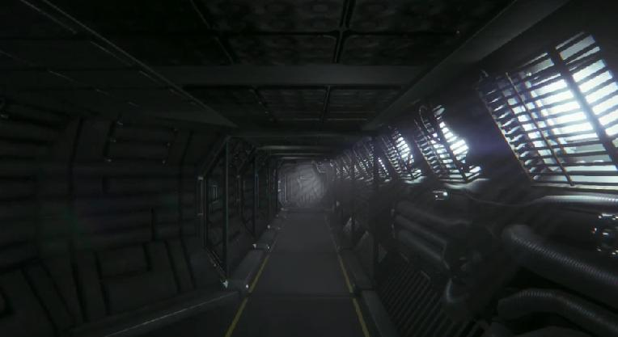

(“Alien: Isolation” - Tight, enclosed environments with dark lighting and atmosphere to enhance suspense and fear, leaving little room for the player to run while encountering the enemy)

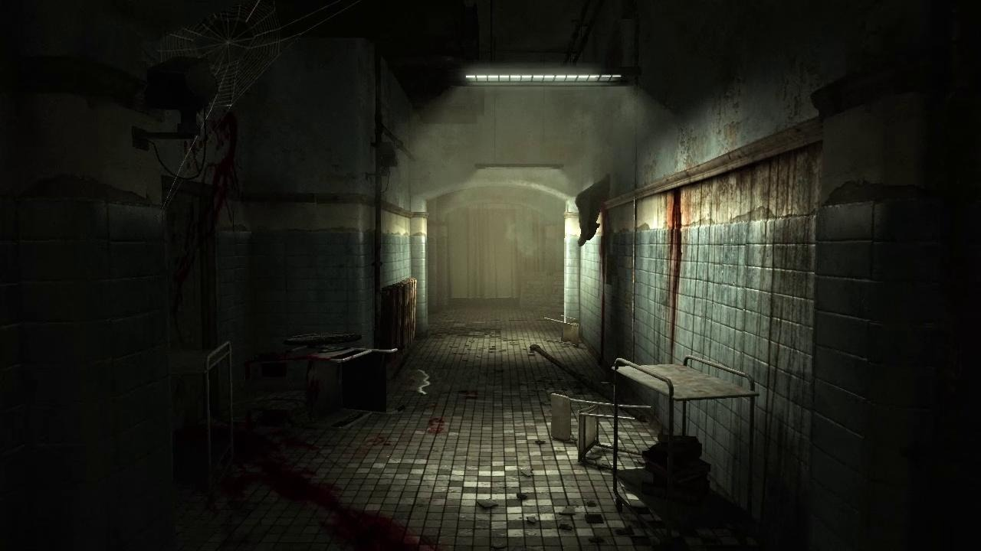

(“Outlast” - Dark lighting and eery atmosphere with scattered medical equipment will tell the player that this place had been used for medical reasons or experimentation of some sorts)

### 

### 

### 

### Sound Pillar

Sound must create a feeling of suspense and horror within the player. They will be filled with paranoia with each sound they hear, questioning whether or not they are safe.

* **Global**
  + **Environmental**
    - Hollow ambient noises such as water dripping, metal settling, air ventilation system humming.
    - Minimalistic dark ambient music that builds dramatically during encounters.
  + **Player**
    - **Walking**
      * Slight echoing footstep sounds;
      * Breathing sound;
    - **Crouch**
      * Very light footstep sound;
    - **Sprinting**
      * Louder echo and increased speed of footstep sounds;
      * Heavy breathing sound that increases the longer the duration of sprint;
      * Heartbeat increase based on duration of sprint;
* **Situational**
  + **Environmental**
    - Radio playing at certain points to throw the player off making them feel uneasy as the music is contrast to what the setting is. (eg. “The Ink Spots - I don’t want to set the world on fire”, in a “Outlast” setting.)

##### Seeing enemy

* + - Sudden high pitch violin track that lasts for [2] seconds;
      * This will immediately put the player in a state of suspense and paranoia.
    - Heartbeat instantly increase;
      * The increase of sound and speed of the heartbeat will tell the player that their PC ( playable character) is scared and this will cause the player to be put into a state of suspense and paranoia to why the PC is having that emotion.
    - Heavy breathing instantly increase;
      * Frantic breathing will show that the PC is in a state of panic and the player will have to act on this panic. During so they will be feeling fear and paranoia as well as a rush.
  + **Killed by monster**
    - If the player is caught by the monster, the screen will go black and the PC will have a final last gasp of air, shocked and paralyzed by fear that’s all she can get out. The monster will then let out a menacing growl followed by the sound of breaking bones. After a second of silence the screen will fade back in and have the player standing at their last checkpoint.
      * This will cause the player to feel a plethora of emotions.
        + The sudden gasp of air as the screen goes black will cause the player to feel panic
        + The low menacing growl is give a sense of helplessness and impending death.
        + The sound of breaking bones will give a grotesque end and the player will be off put and feel uneasy.
  + **Open Doors**
    - Doors are somewhat sci-fi, heavily inspired on the Alien Franchise.
    - See first seconds of alien isolation gameplay for opening door sound reference (<http://tinyurl.com/lxporun>)

## 

## Features

### Core Features

* Use your tablet to view the various hallways and rooms ahead of you to plan your next move.
* Manipulate objects either with your character physically or electronic objects remotely with the cameras.
* Use various paths and methods to avoid the enemy or hide from it.

### Supporting Features

* Audio logs and journal pages scattered throughout the environment, providing backstory to where the player is.
* In-Game help text/ hints (toggled)

## 

## Product Differentiation & Innovation

### What makes this game different?

### Old Features and Gameplay Elements

Our game follows the pacing and tension building structure of psychological horror games such as “*Resident Evil 1 & 2”* or “*Outlast”***.**

Hiding within lockers or underneath desks to hide from the enemy.

### Improved Features and Gameplay Elements

The 3rd person view (While in camera view) found in old “*Resident Evil”* games improved in a way that feel natural for the player, because now it is toggleable. It is possible to access cameras all around the map using your tablet, which toggles the third person view, but by putting the tablet down the player goes back to first person, allowing him to approach situations the way he feels more comfortable.

### 

### Re-Purposed Features & Gameplay Elements

The ability to switch between camera views from games like

*“Five Nights at Freddy’s”****.*** This adds a new kind of gameplay experience because the camera becomes more than a simply a static point of view. The player can aim it at different interactive objects in that room and control them, such as open doors, turn on/off lights and solve small puzzles. The camera serves as different points of view but also as a way to interact remotely with objects.

### New Features & Gameplay Elements

Solving puzzles remotely through the use of multiple camera perspectives.

Using the cameras allowing you to create a plan on how to proceed.

# -Gameplay-

## Player Goals & Gameplay Objectives

### Player Goals

* Beat the game.
* Stay Alive
* Spot a monster before it gets the jump on your character.
* Solve the puzzles.
* Learn how the monsters think to outsmart them.
* Find out what happened in the facility.
* Find out why the monsters exist.
* Get into areas you aren’t necessarily supposed to be able to get too.
* Taunt the monster but purposely finding, getting it to chase you then run.
* Complete the game without being seen.

## 

### Objectives

* Escape the laboratory.
* Survive against dangerous monsters who stalk the halls.
* Solve puzzles to unlock blocked areas.
* Hide from monsters if spotted.
* Distract enemies, leading them away from your position.

## 

## Win Condition

**Escape the laboratory**

Do this by:

* The exit is blocked from the other side. In order to escape the player must find an alternative exit.

To do this they will:

* + Solve environmental puzzles allowing the player to unlock new rooms and cameras.
  + Avoid the enemy stalking the halls by being aware of your surroundings and sneaking around them.

## Mechanics

See document "*Mechanics Feature Brief"*.

*(Blank Feed Team Folder>Team Blank feed Final Folder>Mechanics Feature Brief)*

Link -<http://tinyurl.com/featurebrief>

### 

## The Monster

### Aesthetics

See "*Art Bible*" for reference.

*(Blank feed Team Folder > Art Bible > Art Bible)*

Link - <https://docs.google.com/document/d/1GcY9nKdP7_0M6P21U3xniPoN5tDrNIizqUfK67hDbl4/edit#>

### 

### Mechanics

See "*Monster Feature Brief*" for detailed behaviour, visual, audio, animation and how it should feel like in the game.

*(Blank Feed Team Folder > Team Blank Feed - Final Folder> Monster Feature Brief)*

Link - <http://tinyurl.com/kjprw5m>

## Rewards

* Solving “Missing Item Puzzles” which revolve around security cameras, will unlock vision for the camera it pertains to.
* In Tablet View, the player can click on certain highlighted objects in the environment to cause a temporary distraction for the monster, potentially saving them. These objects have an animation that will play (Create link to a Monster Distraction page, listing all the interactable objects the player can use to distract the monster).
* Solving “Missing Item Puzzles”, “Number Pad Puzzles”, and “Moving Object Puzzles” that pertain to unlocking a new area, will give the player more spaces to run and hide in.

## 

## Punishment & Lose conditions

### Temporary Routes:

* + There will be malfunctioning doors that can only be accessed a set number of times, before the player is no longer able to use them. If used the maximum amount, the player will have to go the longer, more dangerous way. (This needs to be referenced somewhere else to make sure it gets put in. I’m not sure where though)

**Audio logs**

* Logs will fill in back story about the playable character.
* Will give story behind what happened to the facility.
* Gives backstory as to what went on in the labs.
* Audio logs can have password codes for number pad puzzles.

## Gameplay Flow & Structure

Link to the Flow Chart: <http://tinyurl.com/nzrdhtn>

## 

## Player State

Link to Flow Chart:<http://tinyurl.com/qj7ozk4>

* The player has a sense of uneasiness while searching the environment. They don’t know when or how they may encounter the monster, so will they remain alert and on edge.
* The player will feel hesitant if they have to go into tablet view due to not being able to move while in tablet view.
* The player will feel relief when they find an item that will allow them to progress (ie. Passwords or Keycards) or enter a designated safe zone.
* The player will be startled at the appearance of the monster when they first encounter it.

## Gameplay Moments

### Running

#### 

#### Past Moment

The player will have to be knowledgeable of how the controls work (Movement and cameras) so they will have a chance of escaping the monster. In order for the player to get the full experience we’ll need to create a world filled with suspense and unanswered questions. So that when the player finally encounters the enemy it will fill them with panic and fear.

#### Present

In order for the player to get the intended experience, they will need to encounter the monster and be within its line of sight radius to initiate the monsters chase state. The sudden change in gameplay going from a slow and stealthy experience to a high suspense chase sequence leading the player into panicked and rushed state, the player will now have to run from the monster. If they can’t get away fast enough, they will be killed causing the end game sequence.

#### 

#### Next Moment

The player will need be cautious of the their surroundings, constantly checking their cameras due to paranoia and not wanting to run into the monster again. The player will be actively searching for their way out or ways to activate more cameras so they can be prepared if the monster is approaching.

### 

### Searching

#### Past Moment

The player will need to be curious of what’s happening so that they are drawn to investigate their surroundings. But we don’t just want the player to be curious we also want them to be kept in suspense and be cautious as they wander around the environment. So it will be filled with elements that draw out these emotions.

#### Present

In order for the player to continue searching for items that will help them progress we will have to maintain a line of difficulty to keep it interesting. We also need to make the reward blatant because there is a risk to searching and solving puzzles to get through the environment. These risks will include the player being helpless while trying to solve puzzles and if the player stays in one area for too long the monster will find them quicker.

#### Next Moment

The player will now be curious to what else they can find within the environment. May it be more items/ passcodes to open doors or new paths to take to avoid the enemy.

### Hiding

#### Past moment

Before “hiding” the player needs to know this mechanic is possible. They need to be confronted by the monster before an actual chasing sequence happens and the player has no idea how to get around it. This can be accomplished by either explicitly mentioning it in the HUD information or by creating a tutorial room that requires searching and in that process, the player has the option of “hiding” while the monster is in the room.

#### Present

The player *locates/has been seen by* the monster, thus entering the state of running/alert, looking for possible rooms to hide in. For hiding to be successful the player needs to make sure the monster has lost track of them before entering the hiding place, or else it will kill the player. This means hiding should be a fast action, that won’t stand in the way of escaping. Since it is the last step for completion of this ‘puzzle’ it should feel rewarding, acting as a gasp for air after intense fleeing.

#### Next moment

The player will now keep a mental note of the hiding places they may encounter as they make their way through the level. But even though they now know they can hide from the enemy they will still be cautious and wary of their surroundings and try to not run into the monster again as the tension from the previous encounter would still be fresh in their heads.

## 

## Challenge Flow

As the game progresses the puzzles become more intricate, and avoiding the

monsters becomes more difficult.

**Puzzle Difficulty Flow**

Blank Feed’s puzzles can be broken into 4 parts in terms of flow. The first part is the opening sequence with a tutorial level of difficulty and a puzzle in similar

difficulty to solve.

The second part comes in the form of self contained puzzles, where the solution only spans 1 or 2 rooms. These puzzles don’t require any prerequisites to attempt, so they are on the easier side of difficulty.

The third part comes in the form of conditional puzzles, which require a

prerequisite to solve. The solution for these puzzles tends to span 2-3 rooms,

plus meeting a prerequisite.

The fourth and last part is hybrid puzzles. These puzzles require you to solve a

puzzle within a puzzle. These typically span between 2-4 areas.

**Monster Challenge Flow**

The challenge presented from Monster(s) increases in part due to a number of

factors, which become more frequent as the player progresses throughout the

game.

In the beginning there are more places to hide from the monster(s), where as you progress, hiding places become more scarce.

Environments in the beginning are designed so that monsters are very clear

where they are. As you progress, the environments are designed to further

hinder the player, rather than benefiting.

The game starts with the player only having to deal with one monster at a time, as they progress, multiple variations of the same monster are introduced, giving them more kill potential.

## Game Progression

## Help & Tutorials

* Brief in game tutorial of how the tablet system works, which will be integrated into teaching players how puzzle solving works.

## Game Options

* Brightness.
* Audio levels.
* Subtitles (on/off)

## Replaying and Saving

* Replaying and saving are both done in the same area, safe rooms; which are maintenance areas with thick concrete walls, and a thick metal door.
* In these areas the player is safe from attacks, but the camera feed is limited to just outside the room.

## Cheats and Easter Eggs

* There will be debugging cheats, such as invulnerability, teleportation, and no-collide mode, but none of these will be made available for the player.
* There will be nods to other horror games through the use of items and background scenery.

## Game Interface

### 

### Camera

The game has two different camera instances.

The main one is set as a first person point of view. This camera is stable and might have a little offset movement to simulate walking. When running, the camera shifts more and the edges become blurred. This is because running only happens when trying to get away from the monster, so it should feel frenetic and thrilling.

Examples:  
Alien Isolation's first person POV.

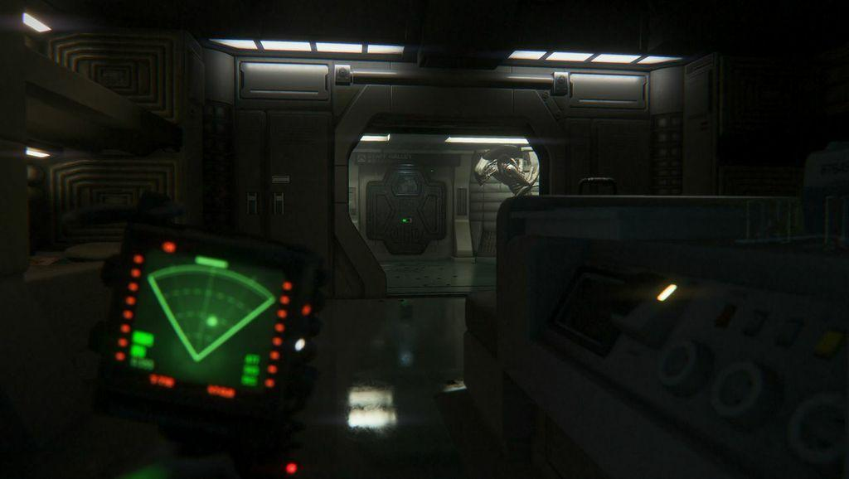

The second camera is toggleable and it depends on the player to pull their tablet and choose from a range of different security cameras to view from. When this happens, the player is still seeing the tablet from their first person view, and it's still possible to get a glimpse of what's going on in the background, but because the camera is focuhe background will be blurred.

The tablet then will be renderising on the tablet tng a 2d projection of another camera, the security camera the player chose from, and he will be able to interact with it, move it around, interact with objects remotely and so forth.

When inside the security camera

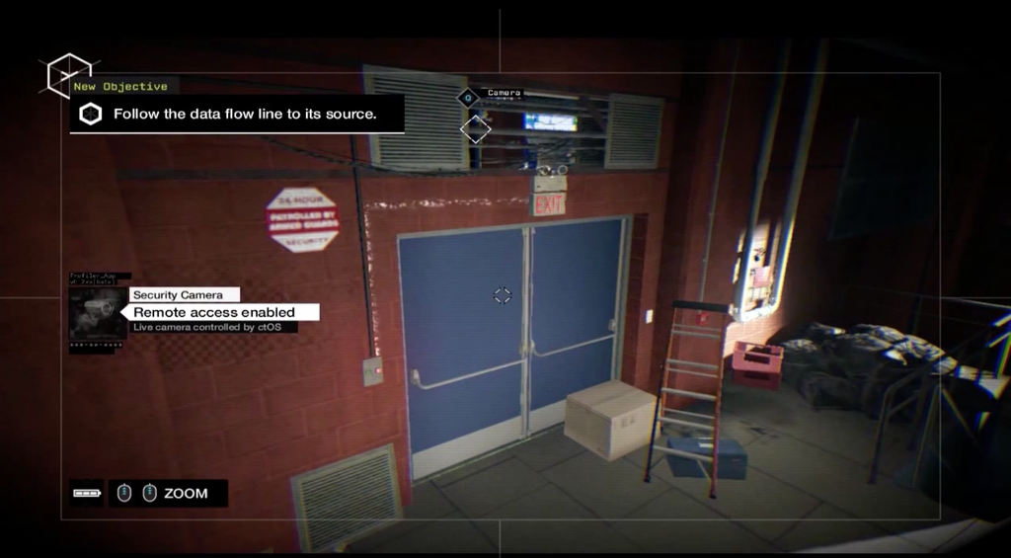

### 

### Information Overlays (HUD)

When playing in the first person camera, the HUD is as minimal as possible, since the information players require during this state it:

* Any sudden warning coming from the tablet
* (For playtesting purposes) A minimal stamina bar that is activated when players sprint, letting them know how much can you still run. In the final build, the idea is this information is going to almost completely replaced by sound cues, heavy breathing, heartbeat increase and as a visual cue, the screen will get blurry and blurry.
* When near an interactive object, a pop up showing which button is required to be pressed to interact with it.
* 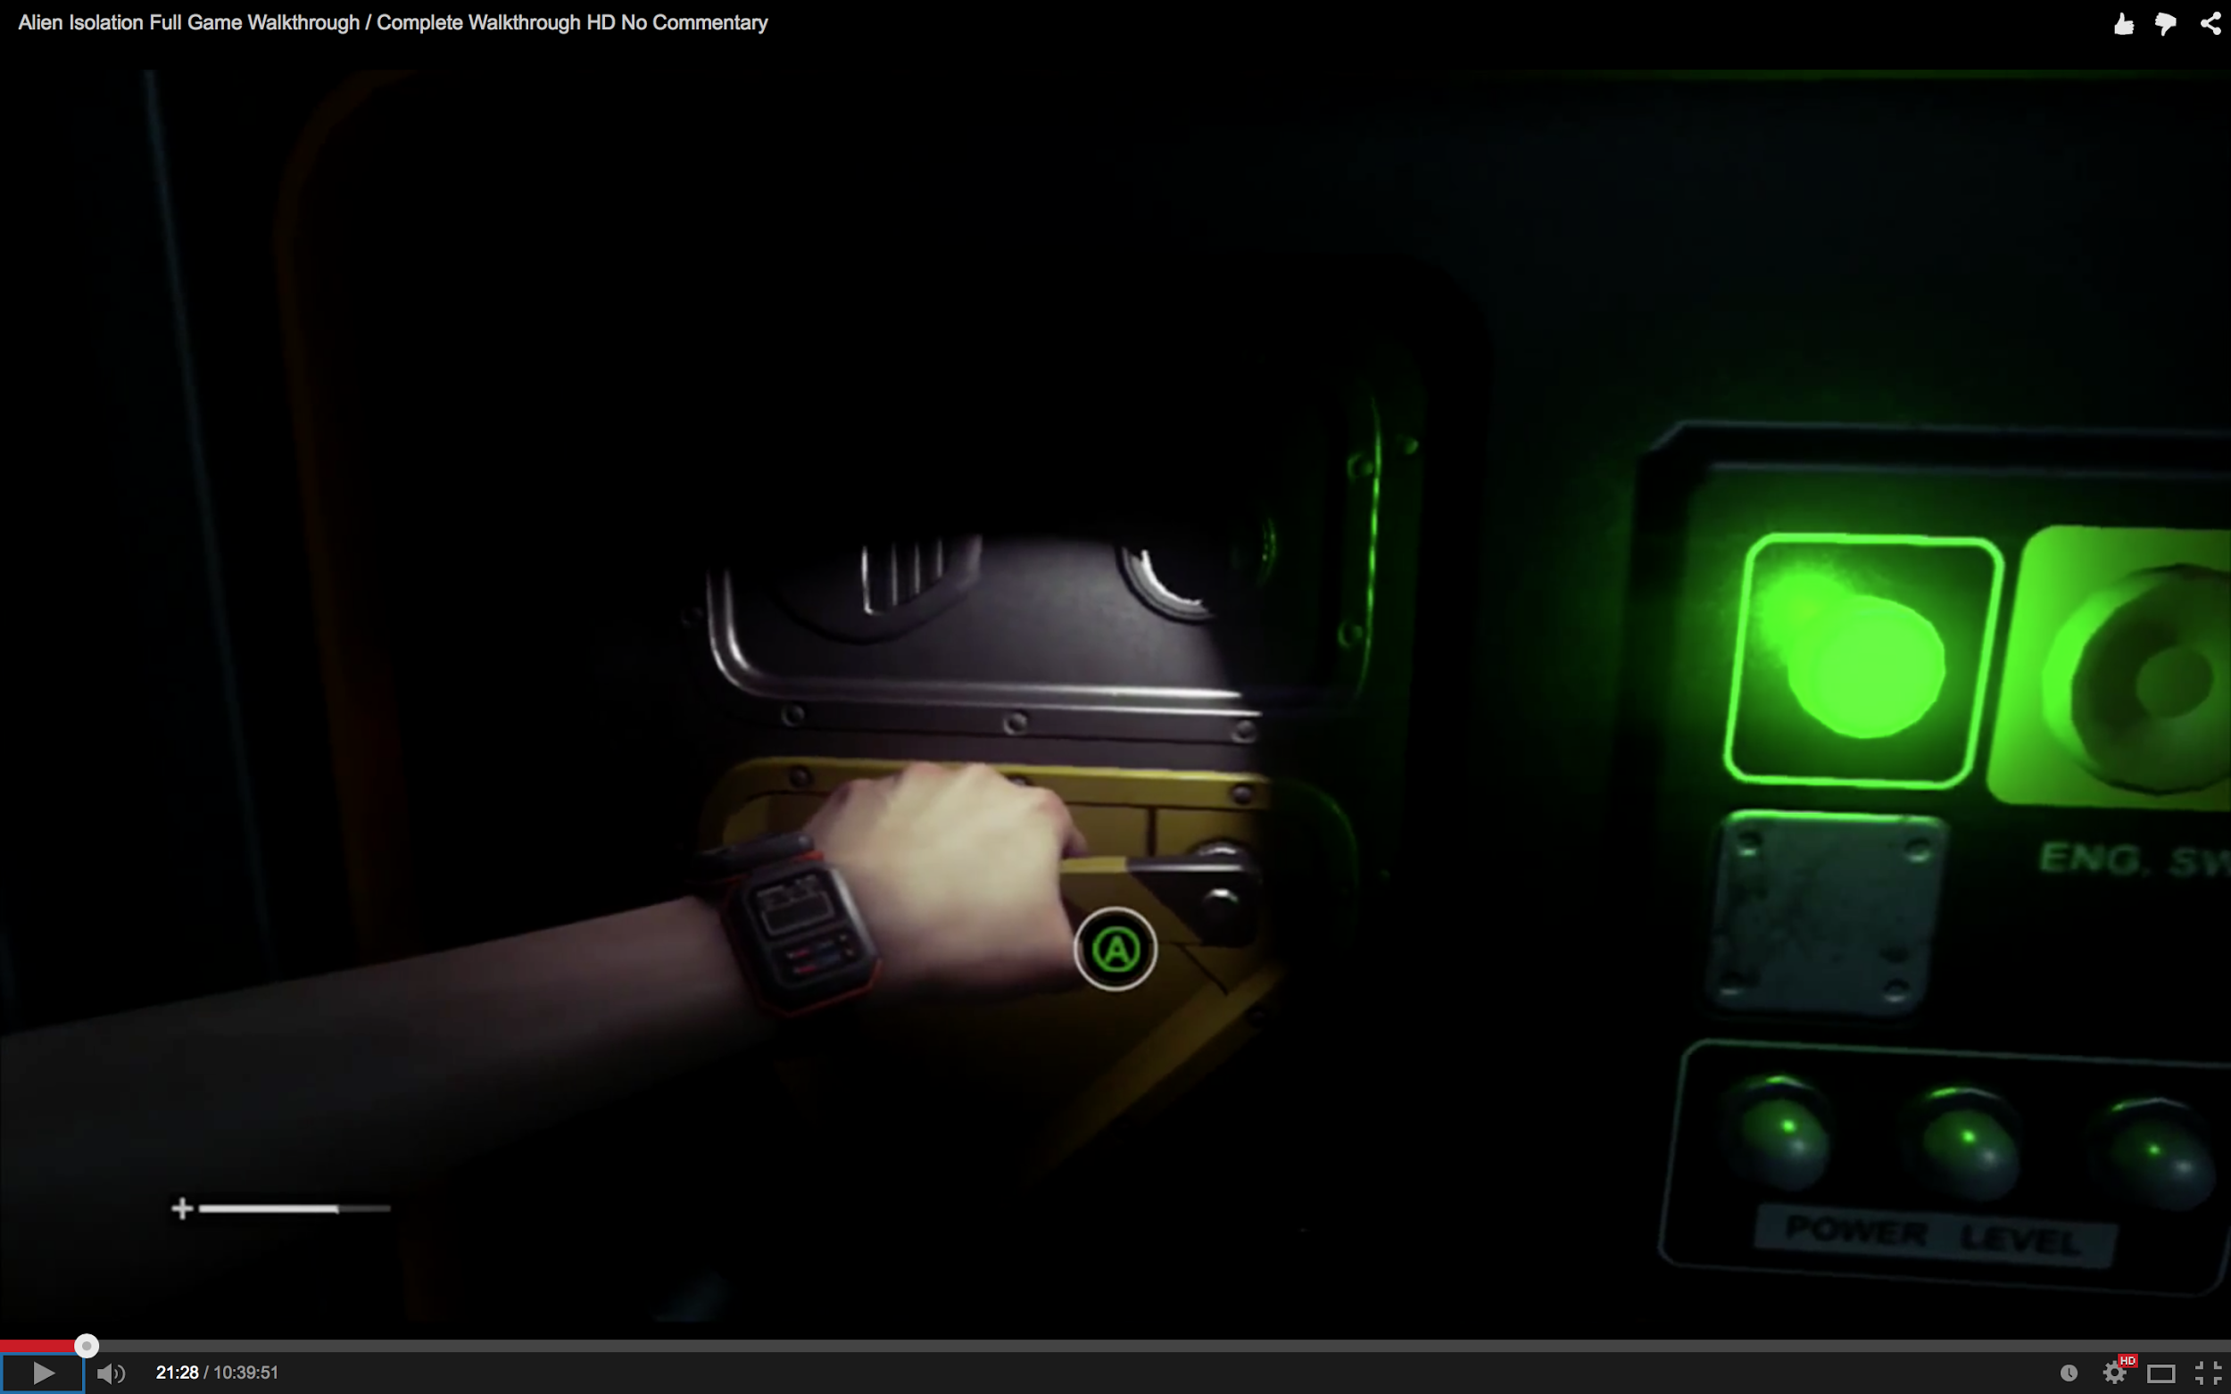

When using the tablet, the HUD gets fairly more complex.

In this state, these are the most important information that should be displayed:

* Which camera am I in right now.
* Where in space am I and how does it interact with other places (minimap)
* Which cameras are interactive and which aren't.
* What is my current mission.
* Where is the mission place in the minimap.
* Which objects are interactive remotely from the camera I'm currently viewing.
* A legend of which controls can I use to interact/control the tablet interface.
* If a camera has sound, how much sound is coming from that camera.

#### 

#### 

#### 

#### 

#### 

#### 

#### 

#### 

#### 

#### Mockups and Reference Images

Mockup version 01:

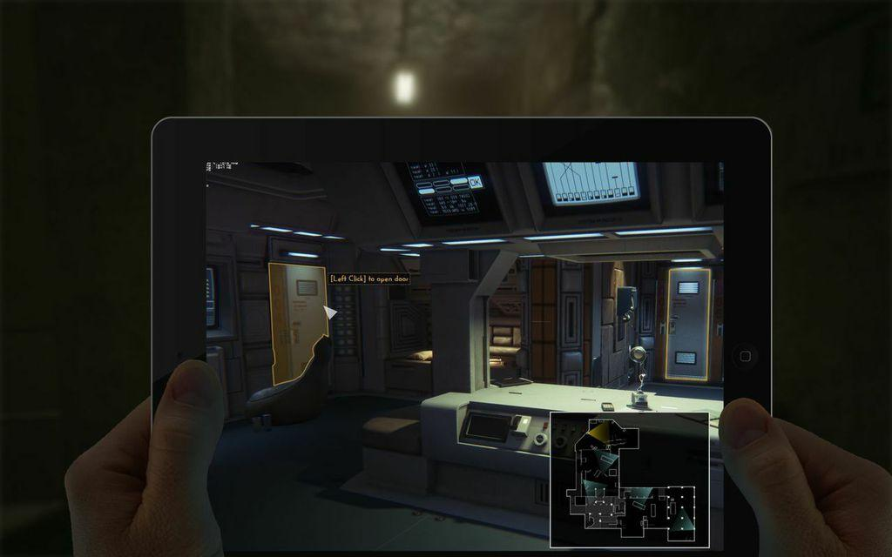

Watch Dogs Camera HUD:



Alien Isolation Mini-map: 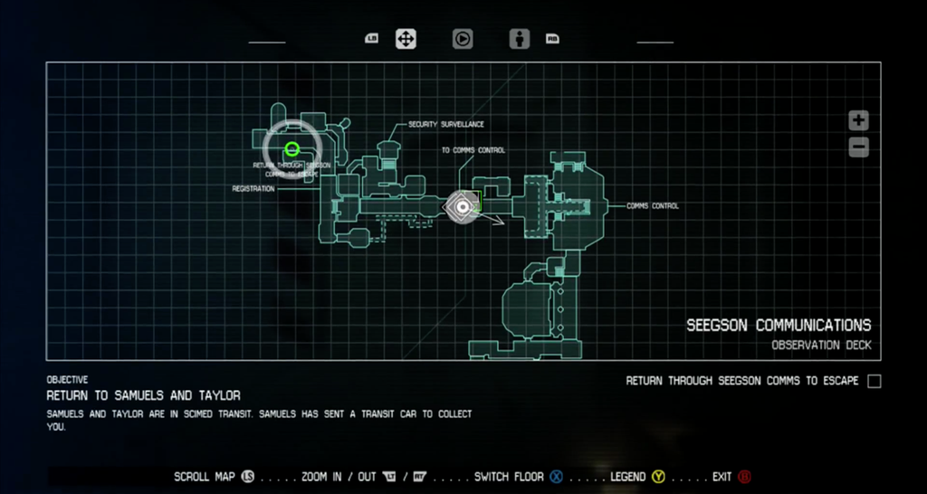

Interactive objects in Alien Isolation:



### User Interface Screens & Menus

### 

### Main Menu

Buttons:

* Start Game
* Options
  + Audio
  + Video
    - Brightness
    - Quality Resolution
  + Controls

**In-game Pause Menu**

Buttons:

* Quit Game
* Restart Level
* Options
  + Audio
  + Video
    - Brightness
    - Quality Resolution
  + Controls

**Player Death Menu**

Buttons:

* Quit Game
* Retry

# -Levels-